The Thought Behind the Project

***Step 1: Various Ideas***

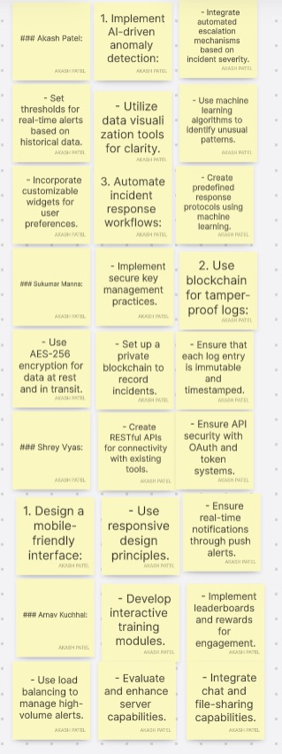

***Step 2: Priority Chart***

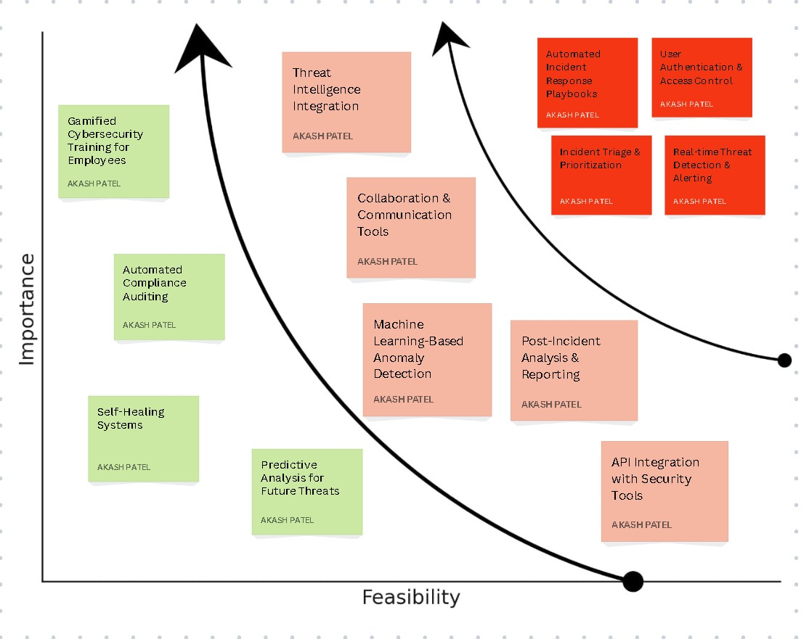

***Step 3: Empathy Map:***

